Swachh Sahayak Pledge Application Documentation

Project Overview
The Swachh Sahayak Pledge Application is a web-based initiative designed to foster community participation and environmental awareness by providing a simple and intuitive platform for individuals to commit to a cleanliness pledge. Upon taking the pledge, users receive an instant email confirmation of their commitment, aiming to build a collective sense of responsibility and encourage sustainable practices within communities.

About Us
Swachh Sahayak is dedicated to empowering individuals to contribute actively to a cleaner and healthier environment. Our goal is to make taking a step towards environmental stewardship as easy and accessible as possible, leveraging technology to facilitate widespread participation in this crucial cause.

Technology Stack & AWS Services Used
This application leverages a modern, serverless architecture on Amazon Web Services (AWS) to ensure scalability, reliability, and cost-effectiveness.
- Frontend Hosting:
  - Amazon S3 (Simple Storage Service): Utilized for securely storing and serving the static website content (HTML, CSS, JavaScript).
- Backend API:
  - Amazon API Gateway: Provides a secure, scalable, and fully managed API endpoint for the frontend to interact with. It acts as the entry point for pledge submissions, directly integrating with AWS SES.
- Email Communication:
  - Amazon Simple Email Service (SES): A cloud-based email sending service directly integrated with API Gateway to dispatch automated confirmation emails to users who take the pledge. This setup directly uses SES without an intermediate Lambda function.
- Core Infrastructure:
  - HTML, CSS, JavaScript: The foundational web technologies used for building the static frontend interface.
- Version Control:
  - GitHub: Used for managing the source code, enabling version control and collaborative development.

Security Considerations & Usage Note
It is important to note that the current deployment of this website is served over HTTP. For enhanced security and data privacy, especially when handling user input, it is strongly recommended to use HTTPS. HTTPS encrypts communication between the user's browser and the server, protecting data from interception and tampering.
Due to potential browser security restrictions related to mixed content (HTTP website calling an HTTPS API), and to bypass local browser caching issues, it is advised to access the application in an incognito or private Browse window for optimal functionality and a consistent user experience during testing and demonstration.

Project Link
You can access the Swachh Sahayak Pledge Application here:
https://staging.d3rpdnsihdxim7.amplifyapp.com/
Code Files
The source code for this project is available on GitHub:
https://github.com/Priyanvi9/Static_website_using_AWS

Feedback
The development of this application offered significant insights into direct AWS service integrations, particularly with API Gateway and SES. While the core pledge capture and email dispatch functionality were the primary goals, the process highlighted the importance of meticulous configuration and detailed error logging in serverless environments. Future enhancements would focus on transitioning the website to HTTPS via AWS CloudFront for a fully secure end-to-end connection, further refining the API Gateway-SES integration, and potentially exploring advanced features like pledge tracking or public display of commitments.

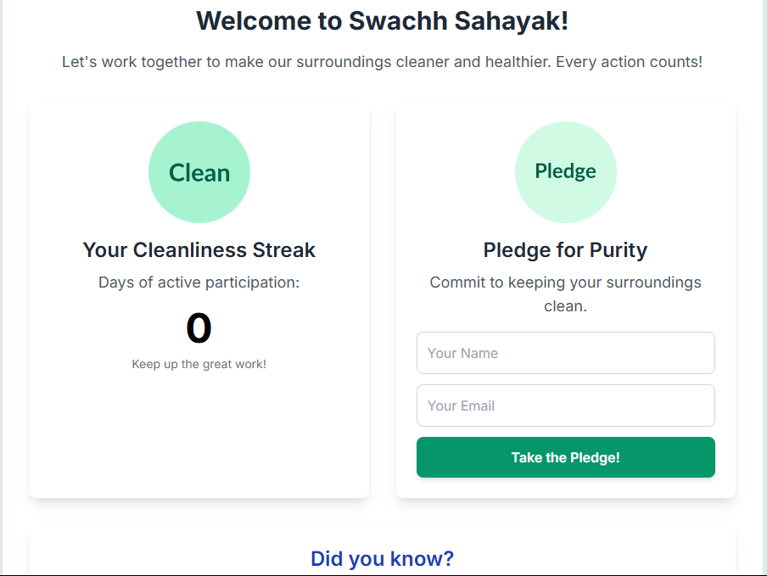
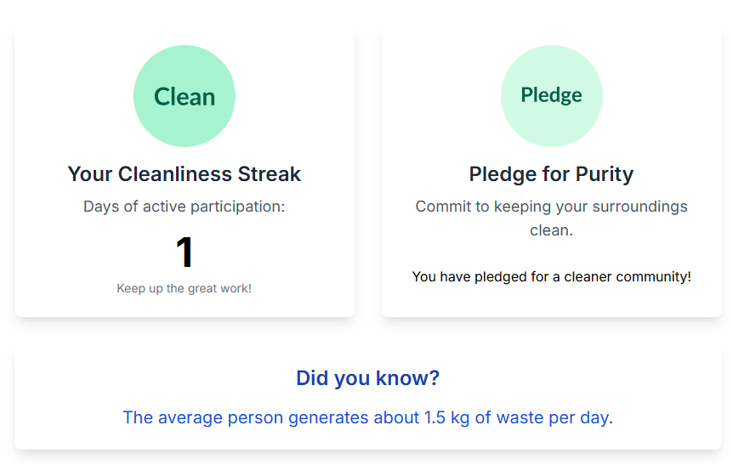

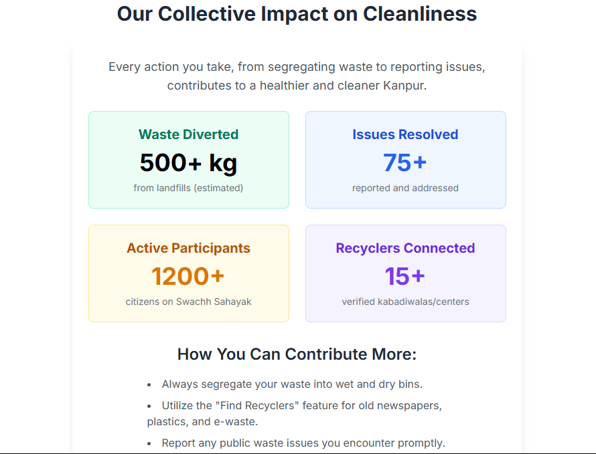
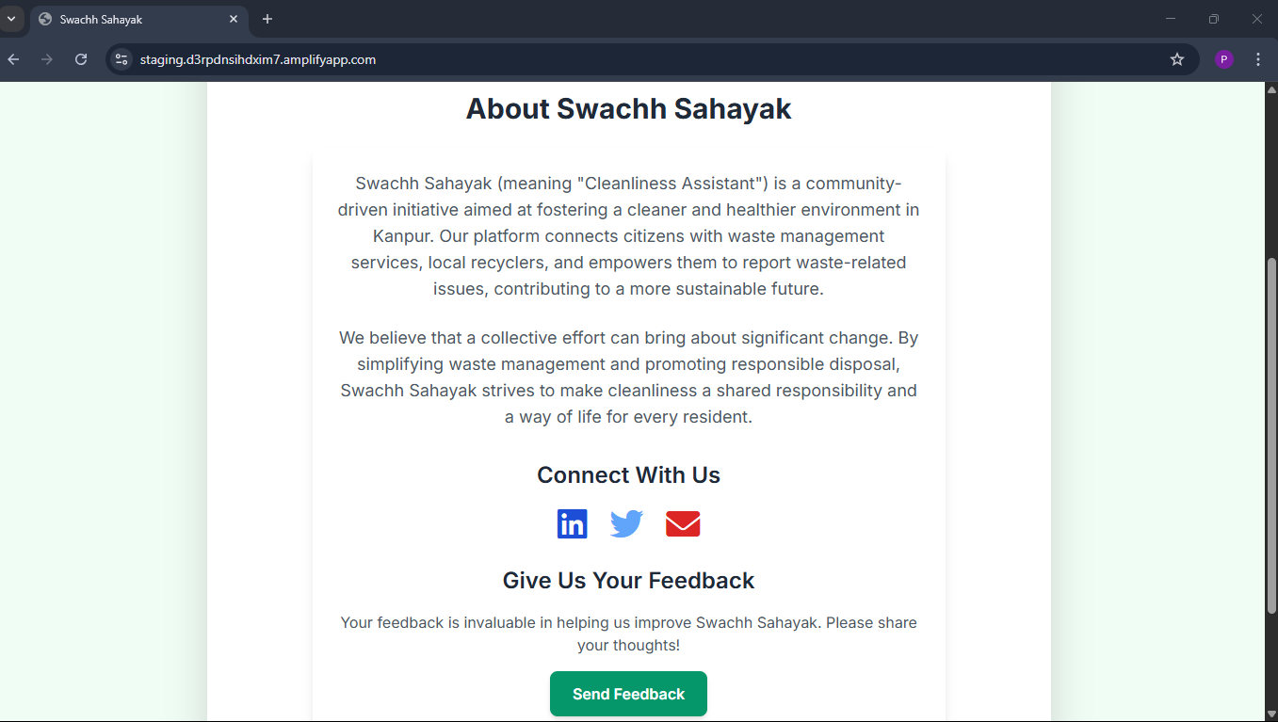
Let's Connect
Feel free to connect for any questions, collaborations, or further discussions about this project or serverless architectures. Your feedback is highly valued!
EMAIL: priyanvigupta869@gmail.com
LINKEDIN: https://www.linkedin.com/in/priyanvi-gupta-993590322/

